USA GYMNASTICS COMPETITION ENTRY FORM 2020 NOR-CAL XCEL S-D SOUTH STATE CHAMPIONSHIP

Name of Meet: 2020 NorCal South Xcel Silver - Diamond State Championships

Hosted by: Gymtowne Gymnastics SSF

Host Address: 389 Oyster Point Blvd., Ste. 5
South San Francisco, CA 94080

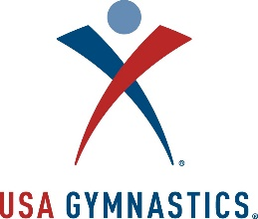

Club: Contact: __________________________________________________________________
Address: _____________________________________________ Phone: ___________________
City: __________________________________State: _______Zip Code: ____________________
Fax: ____________________USAG Club #: ____________Email Address: __________________

Athlete First Name |  | Last Name | Level | USA Gym Athlete Number | DOB | Age | T-Shirt  Y/N | Phonetic spelling of difficult names
1
2
3
4
5
6
7
8
9
10
11
12
13
14
15
16
17
18
19
20
21
22
23
24
25

Coach First Name |  | Last Name | USAG # | Safety Exp | Background | U100 (Y/N)
1
2
3
4
5

COMPETITION LEVELS | NUMBER OF ATHLETES PER LEVEL | ENTRY FEE | TOTAL
Xcel S-D with T-shirt | x | $105.00 | =$
Xcel S-D w/o T-shirt | x | $90.00 | =$
Xcel S-D Late Fee | x | $25.00 | =$
Total |  |  | =$
Please Make Checks Payable to GGE

